Kinematic model computation

Robot frame and parameter table (as defined currently):
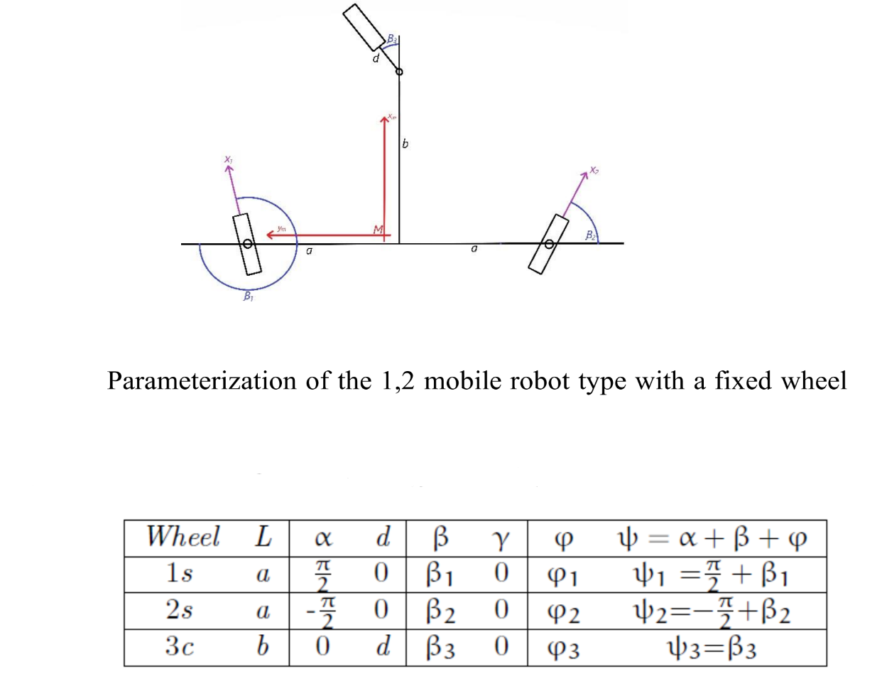

Configuration vector:
q = [x y θ β₁ β₂ β₃ φ₁ φ₂ φ₃ ]

We define some equivalences to have everything in terms of β:

sin(ψ₁) = sin( β₁ + π/2 ) = cos( β₁ )
sin(ψ₂) = sin( β₂ - π/2 ) = -cos( β₂ )
cos(ψ₁) = cos( β₁ + π/2 ) = -sin( β₁ )
cos(ψ₂) = cos( β₂ - π/2 ) = sin( β₂ )

Now we define J₁, J₂, C₁ and C₂:

